Day 12 :
SQL operations - 1

1.Create a table and insert data:
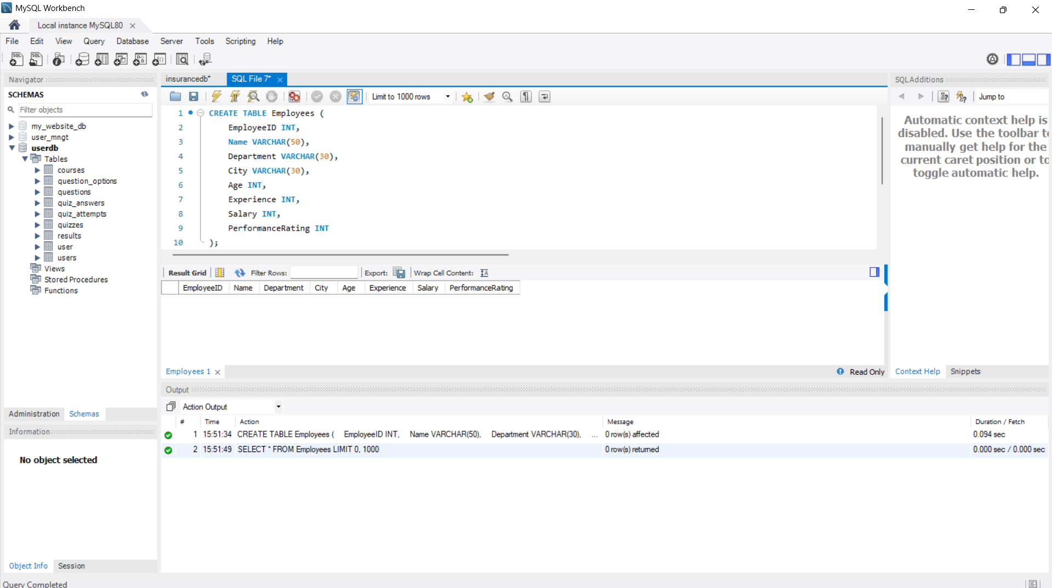

2. Calculate average salary by department:
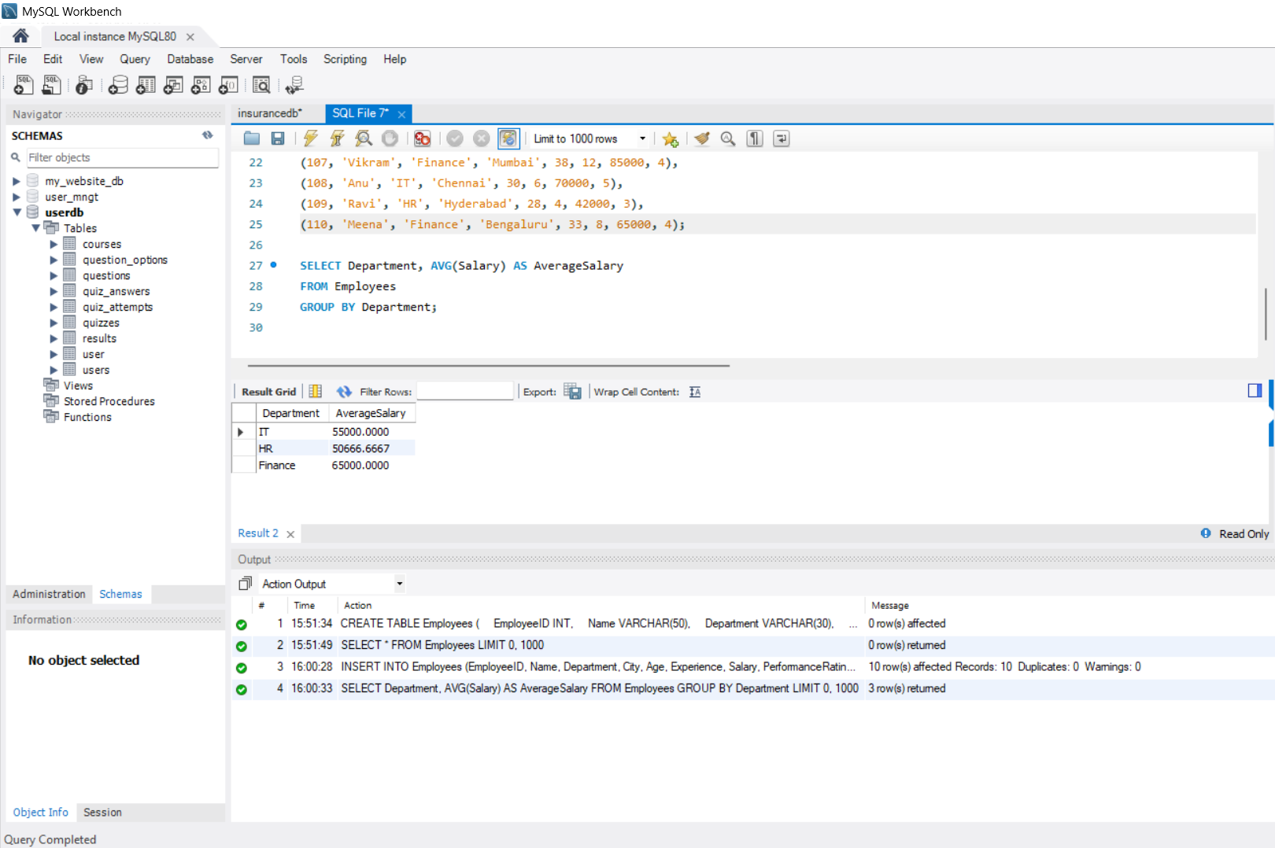

3. Find employees by department:

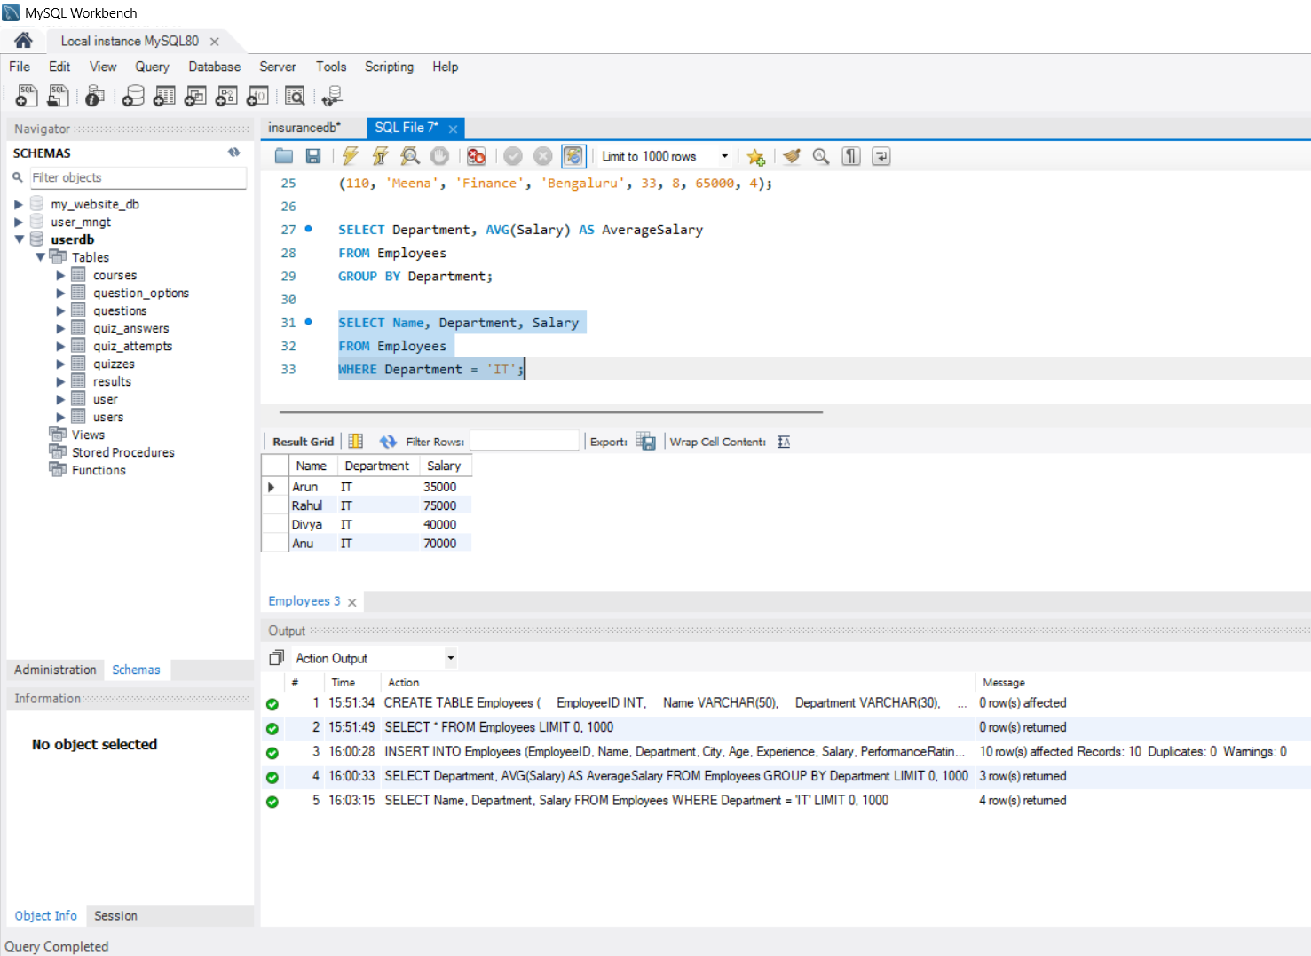

4. Aggregate functions with GROUP BY:
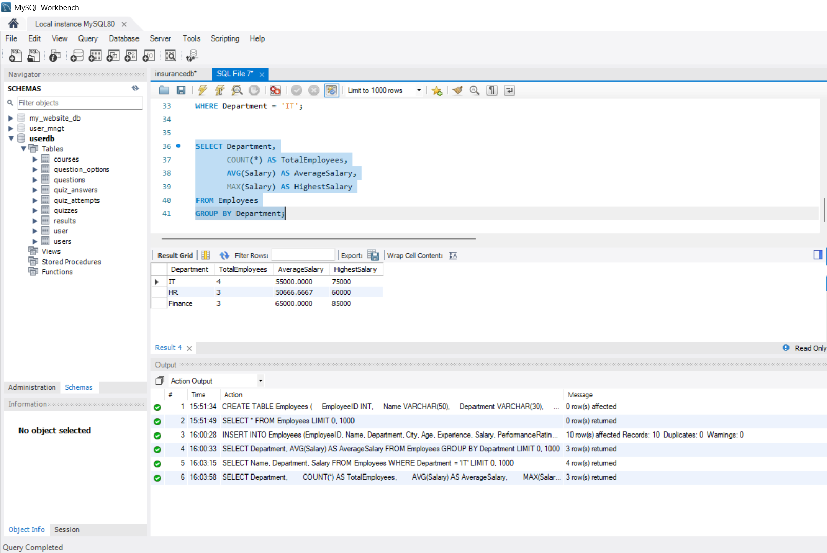

5. GROUP BY with HAVING:
